**PGD002**

**Post Graduate Diploma in Water Hygiene and Sanitation**

**Assignment Module 4**

**Submitted**

**by**

**Alemseged Moges**

**Admission number DDA/003/006/2019**

**December 31, 2019**

ANSWER

1. The following criteria may be used to measure the success of a PPP providing water supply.
2. **Accessibility**: the extent of coverage of the population, and the distance to the water point.
3. **Affordability**: the cost of the water needed should be less than 5% of the household’s income.
4. **Cost recovery**: the cost of providing the water should be claimed back from the population.
5. **Minimisation of non-revenue water**: this should be reduced to 15% or less.
6. **Water quality**: the water should meet national standards for quality.
7. **Operational efficiency**: the quantity of water supplied per capita, and the duration of water supply per day.
8. Emergency response plans can be very broad and can include major regional disasters (such as earthquakes, floods, damage to electrical equipment by lightning strikes), accidents (spills in the watershed), damage to treatment plant and distribution system, and human actions (strikes, sabotage) (Davidson et.al 2005).
   1. The following are six possible causes of water emergencies, three due to natural causes and three due to humans
      1. Three possible natural causes of water emergencies: drought; flooding; earthquakes.
      2. Three possible causes of water emergencies due to humans: accidental contamination of the water supply, microbial contamination of water sources due to human mismanagement e.g. cholera outbreak in some countries; deliberate poisoning of the water supply as an act of terrorism.
9. According to Davidson et. al (2005), an emergency water safety plan is required to ensure safe drinking-water through good water supply practice, in order to prevent contamination of source waters; to treat the water to reduce. or remove contamination that could be present to the extent necessary to meet the water quality targets; and to prevent re-contamination during storage, distribution and handling of drinking-water. Therefore, the possible options for safe water supply during a water emergency are:
   * 1. Delivery of water to consumers by water tanker and/or bottles
     2. Treatment of the water at the household to render it safe (e.g. by boiling).
10. Sanitary inspection of an abstraction point at a river requires:
11. To take an appropriate checklist of questions to ensure that it is inspected thoroughly, and nothing is forgotten. A notebook and pen or pencil is needed to record all the information collected during inspection.
12. Important things to look for include the location of any latrines or other possible sources of contamination (due to farming or industrial activities) relative to the river, the possibility of any landslide or mudflow, a good solid fence, a screen on the intake, the presence of a dam, the presence of a filter and, if a filter is present, that it is operating properly, and whether there is any uncontrolled flow.
13. A Water Safety Plan is necessary to ensure that the water that is produced and delivered to consumers is safe. It also ensures that the chance of an incident disrupting the continuous supply of water is minimised. According to Davidson et.al (2005), generic technology water safety plans should be based on a thorough understanding of the hazards and risks that may threaten each type of technology. These may include, for example, lack of covers on wells allowing direct ingress of contaminated surface water, lack of drains that allow inundation of the wellhead, animal access close to the wellhead leading to the development of pathways into the source and faecal material close the source.
14. The two types of maintenance are breakdown maintenance and preventive maintenance. Preventive maintenance is better because it helps prevent breakdowns and ensures that the assets can be used until the end of their service life. It is a type of proactive maintenance that includes adjustments, cleaning, lubrication, repairs, and parts replacements. It plays crucial role in operations and maintenance of water supply systems (François Brikké and Maarten Bredero, 2003). Preventive maintenance keeps assets in good order and reduces unscheduled downtime and major repairs. By undertaking preventive maintenance, crises which are costly can be avoided. If properly operated preventive maintenance program has an advantage over breakdown maintenance in a way that equipment downtime is decreased and the number of major repairs are reduced; better conservation of assets and increased life expectancy of assets, thereby eliminating premature replacement of machinery and equipment; reduced overtime costs and more economical use of maintenance workers due to working on a scheduled basis instead of a crash basis to repair breakdowns; timely, routine repairs circumvent fewer large-scale repairs and improved safety and quality conditions for everyone. Preventive maintenance follows a scheduled workflow as follows:

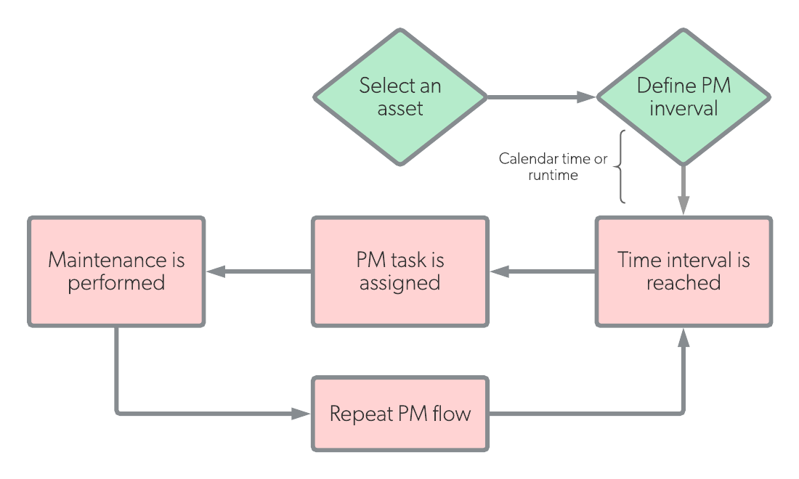

Figure 1: Preventive Maintenance Workflow (source: <https://www.onupkeep.com/preventive-maintenance>)

**References**

Davison, Annette, Howard, Guy, Stevens, Melita, Callan, Phil, Fewtrell, Lorna. et al. (‎2005)‎. Water safety plans: managing drinking-water quality from catchment to consumer / Annette Davison ... [‎et al]‎. World Health Organization.

François Brikk and Maarten Bredero, (2003). Linking technology choice with operation and maintenance in the context of community water supply and sanitation: a reference document for planners and project staff, pp. 12-126